Introduction
Prediction markets have experienced remarkable growth recently, with volume increasing over tenfold from $1.71B to $17.4B in the last year. Kalshi blew up during the 2024 presidential election when their implied odds ended up being more accurate that polling odds, and has more recently been running aggressive advertising campaigns, pushing hard to expand their brand recognition. Polymarket has been on a similar path, running publicity stunts like the NYC free grocery store, and recently be re-legalized in the US. It is clear that prediction markets popularity is on an upward trend and doesn’t appear to be going anywhere as long as legislation allows for it. From an economic perspective, these markets offer a fascinating aggregation of the collective beliefs of their traders. Through financial incentive, they serve as a real time test of the “wisdom of the crowd” by translating beliefs into implied event probabilities.
While much of the media attention surrounding prediction markets covers long-horizon event predictions such as elections, wars, and macro outcomes, there is smaller but equally interesting corner of these markets that operates on a much quicker time horizon. Both Kalshi and Polymarket offer 15-minute Bitcoin and Etherium price direction contracts in which traders place bets on whether or not the BTC or ETH price will be above or below a given spot price for every 15-minute increment of the day. This simple binary question generates a continuous stream of implied probabilities that are updated in real time, creating an unusual opportunity for analysis. Determining whether these probabilities are well calibrated, accurate, and informative will provide essential information about market microstructure as well as algorithmic trading strategies of these markets. This study aims to answer the question: Do Kalshi prediction market probabilities for BTC and ETH 15-minute price direction contain exploitable directional signals, and how do market calibration, intraday seasonality, momentum decay, and cross-asset information jointly determine realized prediction accuracy?

Data Collection
While Kalshi offers an API to interact with market data, granular historical odds are not provided directly. To solve this issue, data sets were built using custom Python scripts that continuously polls the Kalshi Trade API at 10 second intervals. Separate scripts were used and separate data sets were constructed for BTC markets and ETH markets. The script targets the 15-minute price direction contracts, monitoring for and switching between markets every fifteen minutes when new ones go live.
At each 10 second interval, the script computes the mid-price probability of an upward price movement by averaging the best bid and ask prices at that time. This mid-price is labeled as the markets implied probability of an upward movement, P(UP), with P(DOWN) being the implied probability of a downward movement, calculated as 1 - P(UP). To reduce noise, rather than logging every 10 second observation, the script takes the average of the P(UP) and P(DOWN) readings within 1-minute windows throughout the contract. It also creates a momentum term, calculated by the change in P(UP) from the previous minute. This yields 15 data points for each variable every contract period.
Upon market expiration, the script queries the API for the final outcome of the market and updates the CSV. Using this information, it also determines the accuracy of the majority’s predictions at each time stamp. All observations are written to a CSV with the following fields: Timestamp, P(UP), P(DOWN), Momentum, Majority Prediction, Actual Outcome, Correctness, Market ticker, and Volume.
Prior to analysis, a separate Python script was then used to clean the raw data, removing any invalid observations. An observation was considered invalid if it did not have exactly 15 logged data points corresponding to one point per minute, did not have a resolved outcome, or had missing values in any of the columns. Markets failing any of these criteria were dropped entirely. This ensures that the dataset contains only fully observed, resolved, and actively traded market periods, avoiding markets that could bias signal analysis later on.
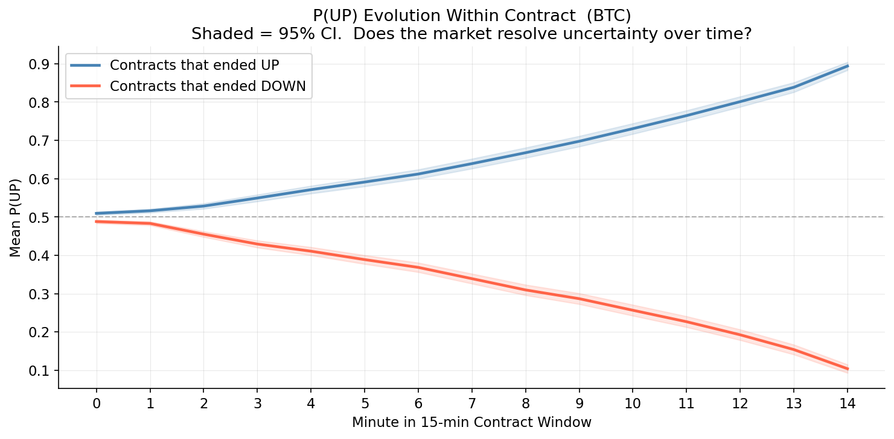
Feature engineering
The data collection process described above yields one observation per minute per contract, up to 15 rows per 15-minute window. Because the outcome is resolved at the contract level, each contract is collapsed to a single row of summary statistics before modeling. Treating within-contract rows as independent observations would violate the independence assumption and artificially inflate the effective sample size. Figure 1 motivates the feature design. Contracts resolving UP show monotonically rising P(UP) from the moment they open; contracts resolving DOWN show monotonically falling P(UP). This divergence establishes that early directional movement carries predictive content beyond the opening probability level and motivates the momentum features that follow.
Three groups of features are constructed using only the first few minutes of each contract, ensuring no future information is used. The first group captures market state at contract open: opening P(UP), conviction spread (|P(UP) - 0.5| x 2, normalized to [0,1]), and log-transformed opening volume. The conviction spread measures how one-sided the market is, independent of direction. The second group captures early directional movement: the change in P(UP) from minute 0 to minute 1, the change from minute 0 to minute 3, and the mean and standard deviation of P(UP) over the first five minutes. The five-minute mean smooths noise from thin early liquidity and, as the SHAP analysis in Section 4 confirms, is the strongest single predictor in the model. The third group tests whether the concurrent ETH contract carries information about BTC outcomes. At any given time, BTC and ETH 15-minute contracts are open simultaneously, priced by participants responding to the same macro environment. Opening P(UP) across matched BTC and ETH contracts is correlated at r = 0.465, suggesting shared underlying sentiment. ETH opening P(UP) and ETH 3-minute momentum, matched to the same BTC contract open timestamp, are included to test whether this co-movement provides predictive value beyond the BTC signal alone.
Feature | Description
opening_pup_btc | P(UP) at minute 0
conviction_spread | |P(UP) - 0.5| x 2, range [0,1]
volume_log | log(1 + opening volume)
momentum_1min | P(UP)[t=1] - P(UP)[t=0]
momentum_3min_btc | P(UP)[t=3] - P(UP)[t=0]
mean_pup_5min | Mean P(UP) over first 5 minutes
pup_vol_5min | Std of P(UP) over first 5 minutes
opening_pup_eth | ETH P(UP) at matched contract open
momentum_3min_eth | ETH P(UP)[t=3] - P(UP)[t=0]
btc_eth_divergence | BTC P(UP) minus ETH P(UP) at open (XGBoost only)
Table 1. Contract-level feature set. The divergence term is excluded from logistic regression because it is a linear combination of the two opening P(UP) features, which causes a collinearity problem.

Modeling approach
Three models are estimated in sequence to isolate the contribution of each feature layer. The baseline logistic regression uses three features: BTC opening P(UP), BTC 3-minute momentum, and hour of contract open. These are the most direct signals available at contract open and this model sets the floor for achievable performance with a minimal specification. Logistic regression is appropriate because the training sets within each cross-validation fold contain roughly 1,000 to 1,500 contracts, too few to support high-dimensional nonlinear models without overfitting risk. Coefficients are directly interpretable as log-odds contributions, which supports the feature importance analysis in the Results section. The extended logistic regression adds the full feature set from Table 1, including ETH cross-asset features, for eleven predictors total. The btc_eth_divergence term is excluded because it is a linear combination of the two opening P(UP) features and produces a singular design matrix.
XGBoost serves as a nonlinear benchmark. Gradient-boosted trees do not require orthogonal features, so the divergence term is reinstated for twelve features total. Hyperparameters are set conservatively (max depth 4, learning rate 0.05, 80% row subsampling) to limit overfitting on the available training sample. SHAP values decompose each prediction into per-feature contributions, providing a model-agnostic view of feature importance that can be compared directly against the logistic regression findings. All three models use 5-fold time-series cross-validation with folds ordered chronologically, so every prediction is generated on data the model has never seen. The majority-class baseline, which predicts UP for every contract, achieves 52.5% accuracy and serves as the reference point for all comparisons. The McNemar test assesses whether accuracy differences between models reflect genuine predictive improvement or random variation in error patterns.

Results
Table 2 reports out-of-sample performance across all three models on 1,595 contracts from the held-out folds.
Model | Accuracy | AUC-ROC | Sharpe (no fees)
Majority baseline | 52.5% | 0.500 | -
Baseline LR (3 features) | 64.4% | 0.703 | 28.4
Extended LR (11 features) | 65.4% | 0.692 | 29.5
XGBoost (12 features) | 65.1% | 0.694 | 25.5
Table 2. Out-of-sample performance from 5-fold time-series cross-validation. Sharpe computed at a 0.55 conviction threshold with no transaction costs, $1 per trade, annualized by 252 × 26 periods. Sharpe values are not directly comparable to conventional equity Sharpe ratios; see Section 5.

The baseline logistic regression outperforms the majority-class benchmark by 11.9 percentage points in accuracy and 0.203 in AUC-ROC, confirming that three simple same-asset features carry real predictive content. The extended model adds 1.0 percentage point of accuracy. AUC falls slightly from 0.703 to 0.692, meaning the extended model classifies more contracts correctly at the decision boundary while ranking its probability estimates marginally less uniformly across all thresholds. The difference is small.
Figure 3 shows SHAP values from the XGBoost model, which decompose each prediction into the contribution of every feature. Mean P(UP) over the first five minutes is the dominant predictor by a wide margin, confirming that the smoothed early-window signal captures more information than the instantaneous opening probability. Among cross-asset predictors, ETH 3-minute momentum ranks second overall and ETH opening P(UP) ranks above BTC's own opening probability. The concurrent ETH market contributes more predictive power to BTC outcomes than BTC's opening level itself.
To understand why ETH market data is informative about BTC outcomes, the lead-lag relationship between the two markets was tested directly. Figure 2 shows the cross-correlogram between BTC and ETH P(UP) at lags -3 to +3 minutes across 1,920 matched contract windows. Correlation peaks at lag 0 (r = 0.782, p < 0.001) and falls symmetrically at all other lags, with no statistically significant difference between positive and negative lags. Neither market leads the other: both price new information simultaneously. ETH is informative about BTC not because it processes information first, but because both markets are simultaneously exposed to a shared crypto sentiment factor that is sometimes more fully reflected in ETH contract odds at a given open. A concurrent ETH feature captures this shared factor; a lagged ETH feature would not, which is why no lagged cross-asset variable was included in the final models.
XGBoost marginally underperforms the extended logistic regression in accuracy (65.1% vs. 65.4%) while achieving nearly identical AUC (0.694 vs. 0.692). A McNemar test on their out-of-sample prediction disagreements yields p = 0.866. The difference is not statistically significant. Adding nonlinear interactions through gradient boosting does not improve on a well-specified logistic regression. The prediction market signal is approximately linear: the market aggregates available opening information in a way that leaves little nonlinear structure for a more complex model to exploit.
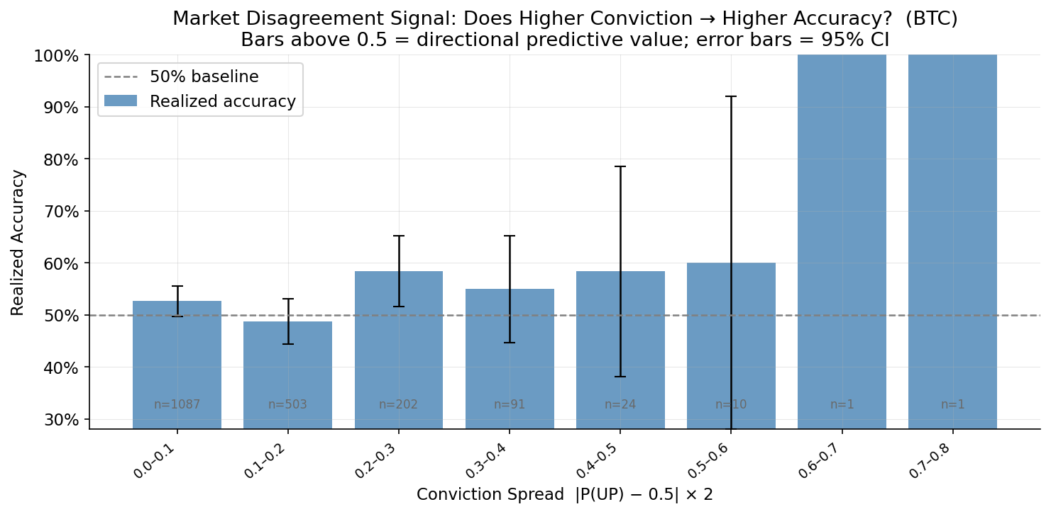
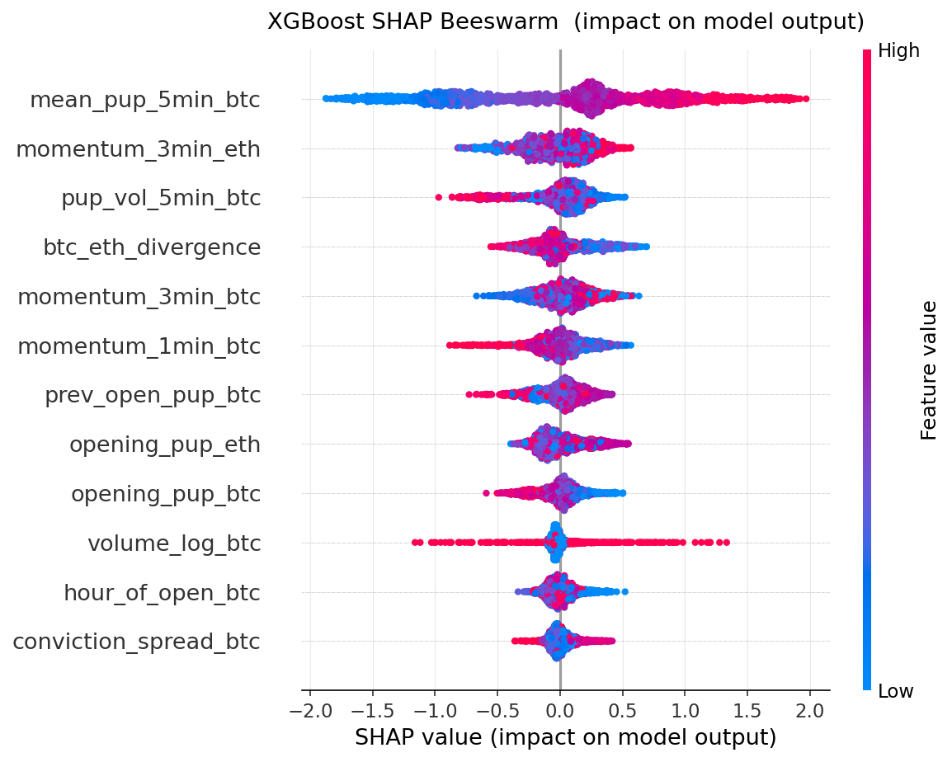
Backtesting
To assess the economic value of the classification signal, a backtest is run on out-of-sample extended logistic regression predictions. Predictions come exclusively from the time-series cross-validation pipeline: the model is never trained on the contracts it predicts. A position is entered when predicted P(UP) exceeds a threshold; contracts that do not clear the threshold are skipped. The payoff is binary: +$1 for a correct prediction, -$1 for an incorrect one, with a $1 stake per trade and a starting portfolio of $1,000.
Table 3 reports results across a threshold sweep from 0.50 to 0.70.
Threshold | Trades | Hit rate | PnL | Sharpe
0.50 | 1,595 | 65.4% | +$491 | 26.2
0.55 | 1,368 | 67.1% | +$468 | 29.5
0.60 | 1,136 | 69.1% | +$434 | 33.5
0.65 | 910 | 71.5% | +$392 | 38.6
0.70 | 694 | 73.9% | +$332 | 44.1
Table 3. Threshold sweep for extended logistic regression, no transaction costs. As the threshold rises, the model only trades its highest-conviction predictions, which improves hit rate but shrinks trade count and cumulative PnL.
Annualized Sharpe increases monotonically from 26.2 at threshold 0.50 to 44.1 at threshold 0.70 (Figure 5). The underlying hit rate rises from 65.4% to 73.9% across the same range, confirming that higher thresholds select for contracts where the model is genuinely more confident rather than simply filtering by an arbitrary cutoff. Cumulative PnL falls with threshold as fewer trades qualify, so the optimal threshold depends on whether the priority is total return or risk-adjusted return.
Figure 4 plots cumulative portfolio value for all three strategies against SPY and BTC-USD buy-and-hold over the OOS period. All three model strategies produce steady upward trajectories. SPY declined over the same window and BTC-USD fluctuated with substantially higher variance. The strategies accumulate returns independently of the broader market direction, consistent with the signal reflecting short-term prediction market dynamics rather than directional crypto exposure. The extended LR strategy generated a maximum drawdown of -$10 against cumulative PnL of +$468, a 2% drawdown-to-PnL ratio that reflects the consistency of the return profile.
The strategy is robust to transaction costs. At threshold 0.55, cumulative PnL falls from $468 at TC=0% to $461 at TC=0.5%, a $7 reduction across 1,368 trades (Figure 6). The binary $1 payoff per trade is large relative to realistic per-trade fee levels, making the strategy structurally insensitive to fee assumptions within the tested range. Since Kalshi's live fee structure and bid-ask spreads are not incorporated, these results represent a bound on performance rather than a deployable estimate.
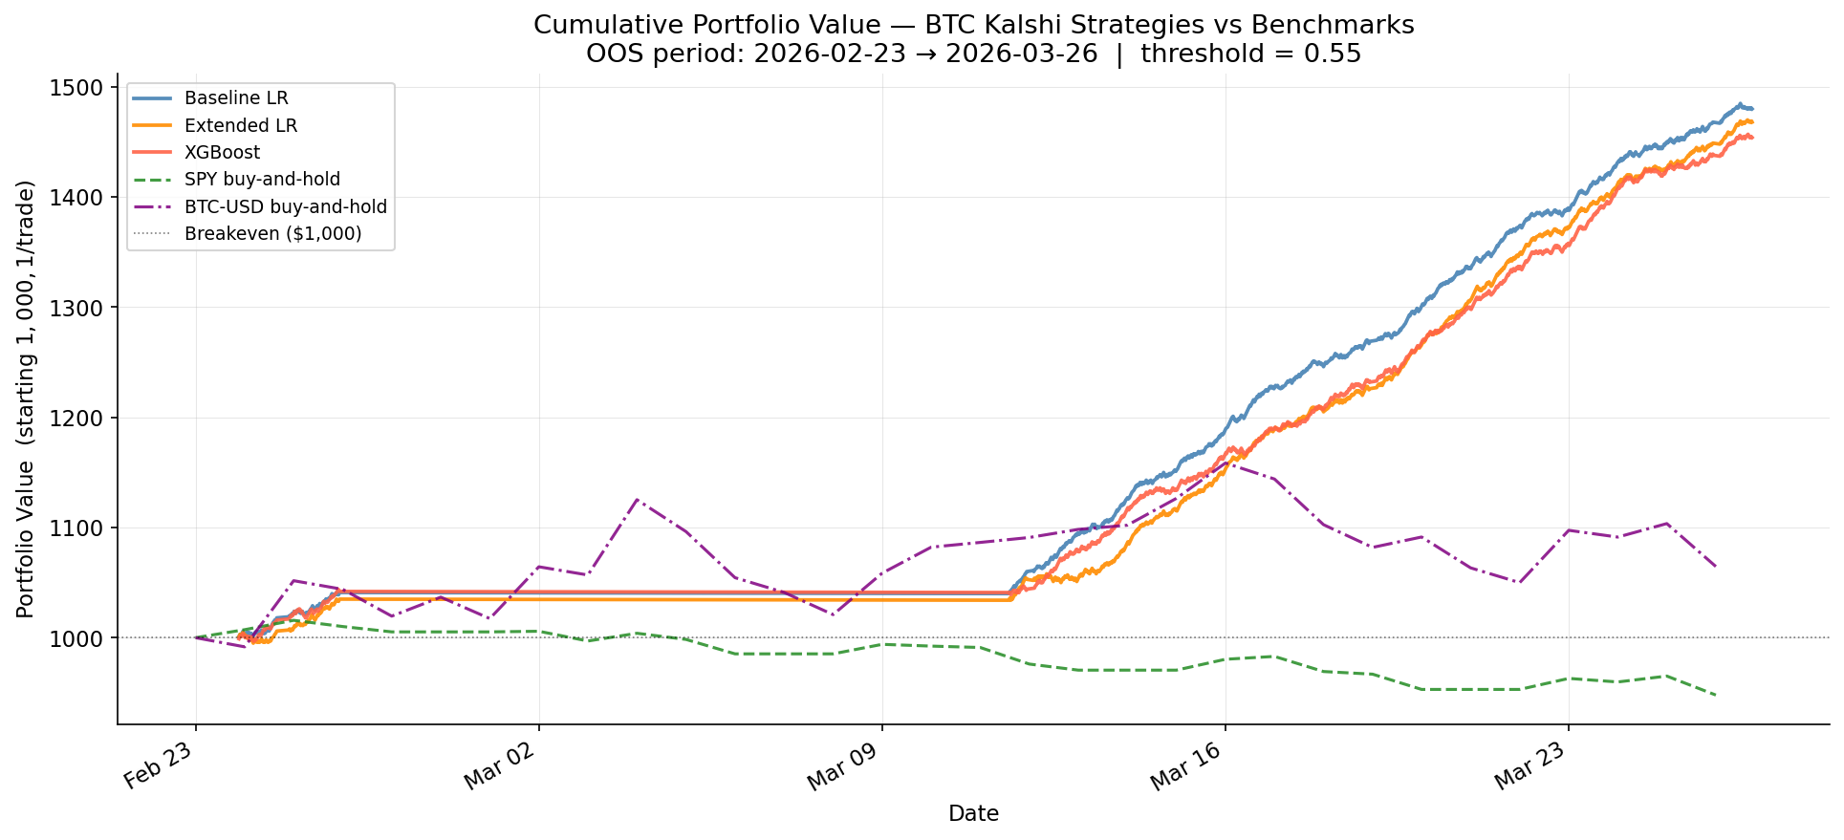
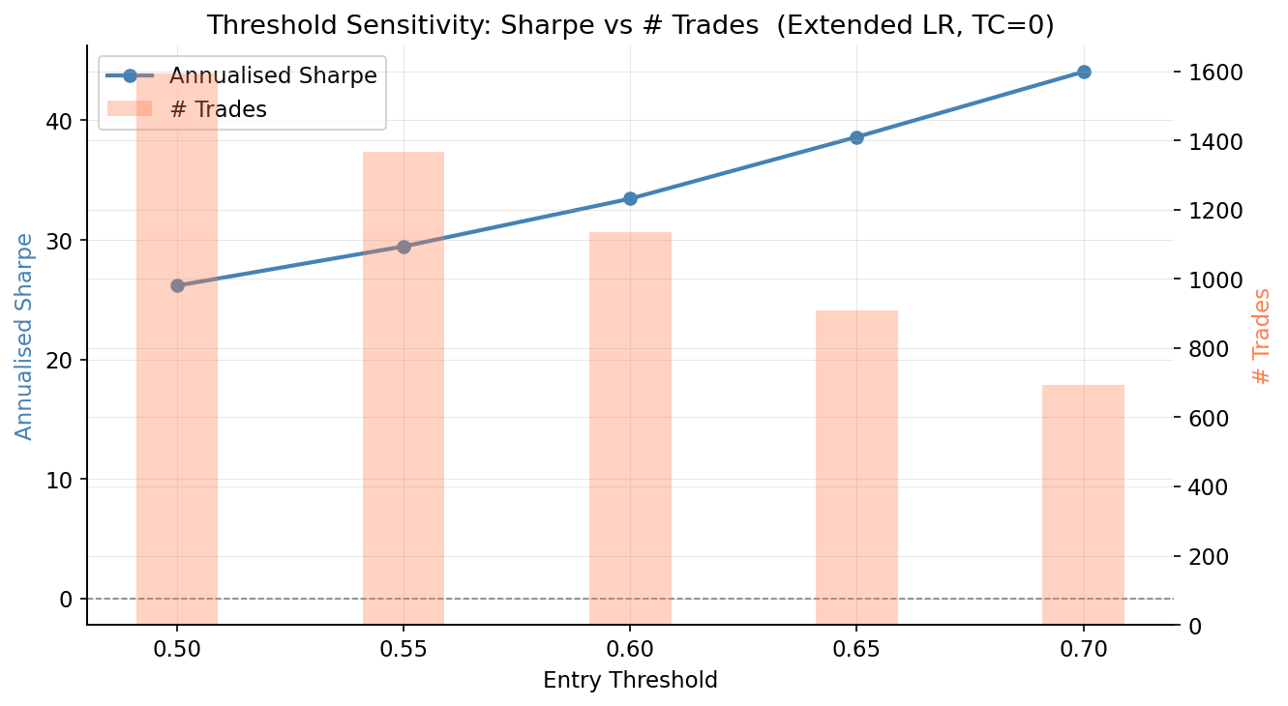
Limitations
The primary constraint is the length of the data window. Six weeks results in approximately 2,200 BTC contracts and 1,900 ETH contracts, enough to identify and validate a signal but representing a single market episode. Whether the cross-asset finding generalizes to high-volatility regimes or structurally different market conditions is untested.
The Sharpe ratios of 26 to 44 should be interpreted in context. They are computed over traded contracts only, excluding flat positions, and annualized by 252 × 26 = 6,552 fifteen-minute periods. This convention produces figures that are not directly comparable to conventional equity Sharpe ratios, which are computed over calendar returns including non-trading periods. A 65% out-of-sample accuracy rate and $468 cumulative PnL over 1,368 trades at zero transaction costs represent a genuine edge, but the Sharpe figures overstate it relative to standard benchmarks. The backtest assumes fills at the conviction threshold crossing with no slippage, which is optimistic for a market with limited liquidity. The model is static and does not retrain as conditions change. A live implementation would require periodic retraining and monitoring for regime shifts.
Robustness and Sensitivity
Three robustness checks confirm that the main results are not artifacts of specific modeling choices or parameter settings.
The cross-validation design prevents look-ahead bias by construction. All five folds are ordered chronologically: training always precedes testing in calendar time. The StandardScaler is fit within each training fold and applied only to the corresponding test fold, so no distributional information from future contracts leaks into feature standardization. All accuracy, AUC, and Sharpe figures reported above are out-of-sample.
The threshold sensitivity analysis in Figure 5 confirms that the signal does not depend on a specific threshold choice. Sharpe is positive across the entire range from 0.50 to 0.70, and the monotonic relationship between threshold and hit rate confirms that the model is correctly ranking contracts by confidence level. A model fitting noise rather than signal would not show this orderly improvement in win rate as higher-confidence trades are selected.
The transaction cost sensitivity analysis in Figure 6 shows Sharpe declining by less than 2% when per-trade costs are raised from 0% to 0.5%. This robustness follows directly from the payoff structure: a correct prediction pays $1 regardless of the contract's opening probability, while realistic transaction costs are a small fraction of that payoff.
The McNemar test result (p = 0.866) is itself a robustness finding. XGBoost has access to nonlinear feature interactions, a richer feature set, and 300 estimators, yet it does not improve on logistic regression. If the out-of-sample edge came from complex nonlinear patterns specific to the training period, XGBoost would have an advantage. The fact that it does not suggests the signal reflects a stable linear structure in how these markets aggregate information, not an artifact of the data window.
Conclusion
This paper tests whether Kalshi 15-minute BTC prediction market probabilities contain an exploitable directional signal and whether incorporating concurrent ETH data improves on same-asset models alone. Three findings emerge.
The signal is real. All three models outperform the majority-class baseline by approximately 12 percentage points in out-of-sample accuracy. The backtest produces positive returns across the full OOS period, at every threshold level from 0.50 to 0.70, and at transaction cost rates up to 0.5% per trade. The return profile is uncorrelated with SPY or BTC buy-and-hold direction, indicating the edge comes from short-term prediction market dynamics rather than broad directional exposure.
Cross-asset information matters. ETH features outrank BTC's own opening probability as predictors of BTC outcomes, as confirmed by SHAP analysis. The lead-lag test establishes that this is not because ETH processes information first: both markets respond simultaneously (peak correlation at lag 0, r = 0.782, p < 0.001). ETH contract odds serve as an independent measure of the shared crypto sentiment factor that drives both markets, and including this concurrent signal meaningfully improves BTC prediction.
The signal is linear. XGBoost does not improve on logistic regression despite access to nonlinear interactions and a larger feature set (McNemar p = 0.866). The Kalshi market aggregates opening information in a roughly linear way, with no hidden nonlinear structure for a more complex model to exploit.
These conclusions are bounded by the sample. Six weeks of data represents a single market episode, and the cross-asset relationship may not hold under different volatility regimes or with a larger and more diverse trader base. The backtest uses a simplified binary payoff model and assumes immediate execution at the conviction threshold crossing; actual trading would face bid-ask spreads, exchange fees, and execution latency that are not modeled. Extending the sample across multiple market regimes and incorporating realistic execution costs are the primary directions for future work.

